Fly Ladakh Ex-Mumbai
07 Nights / 08 Days | 4N Leh – 1N Ulley – 1N Nubra – 1N Pangong

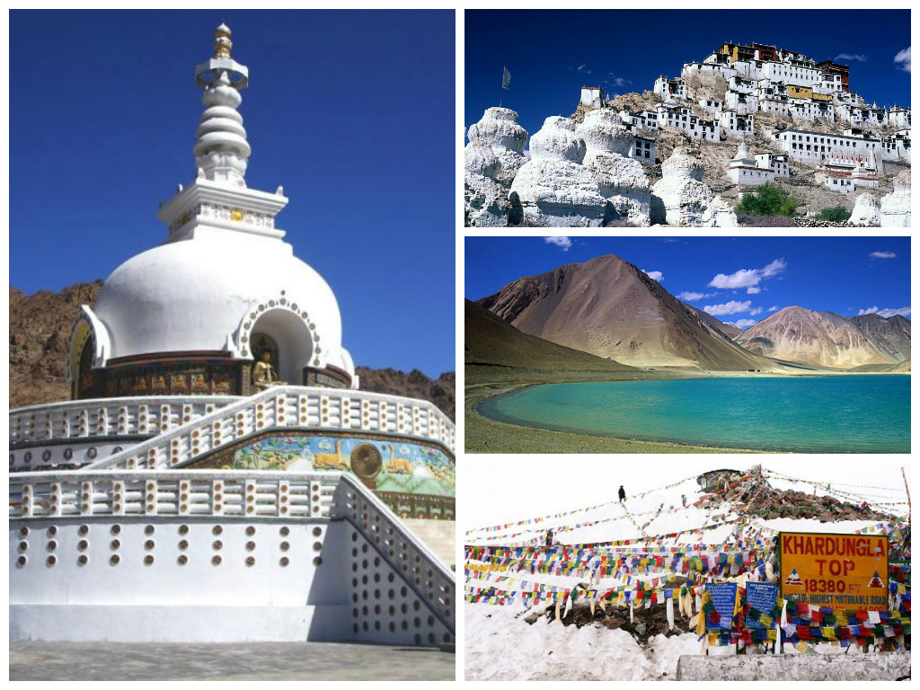
PACKAGE HIGHLIGHTS:

- Return airfare from Ex-Mumbai
- In Leh, visit Shanti Stupa and Leh Palace
- Centuries old monasteries in Ladakh – Hemis, Shey, Thiksey, Diskit…
- Visit & Stay at world’s highest salt water lake – Pangong Lake
- Drive through world’s highest motorable passes – Khardung-la & Chang-la
- Stay in Nubra valley and visit to Sand Dunes
- Airport transfers and local sightseeing tours by private vehicle
- Start and End in Mumbai

ITINERARY:

Day 01 Arrive in Leh (3505 meters / 11567 feet)
Arrive Kushok Bakula airport Leh - 3500m above sea level. Transfer to hotel. Breakfast at the hotel before 09.30 am. Half day at rest for acclimatization. After lunch drive to visit Shanti Stupa & Leh Palace, Later in the evening walk around local market. Overnight stay at the hotel at Leh.

Day 02 Leh – Alchi – Lamayuru – Alchi/Ulleytokpo (210kms/ approx 6 hrs)
After breakfast, start sightseeing of 1000 year old Alchi monastery the only Gompa in Ladakh region on flat ground. Proceed to Moon Landscape & Lamayuru. After visit Lamayuru drive back to Ulleytokpo. Overnight stay at the Ulley / Alchi.

Day 03 Ulley – Leh (70kms/ approx 2.5 hrs)
After breakfast departs Alchi/Uleytopko. Thereafter proceed to the Likir Monastrey to visit the splendid three storeys Dharma Wheel Gompa. Here you'll be awestruck with the sight of the massive Buddha statues., Indus & Zanskar river sangam, drive along the Indus river visiting, Pathar Sahib Gurdwara and Magnetic Hill (where the cars defy gravity), Basgo Palace Hiking only and further on to Leh Hall of Fame (which has a museum of the Kargil War memorabilia) Dinner and Over Night at the hotel in Leh.

Day 04 Tour of Khardungla Pass 18380 Ft. Nubra Valley & Hundur Sand Dunes (130km /approx 4-5 hrs)
After breakfast drive to Nubra Valley via Khardungla (Highest Motorable road in the World, 18,380 ft) Arrive at Hundur by afternoon. Rest of the day, Post lunch free to explore Diskit, Hundur Villages and Camel Safari in Sand Dunes between Diskit and Hunder Village. Overnight stay at the camp.

Day 05 Visit Diskit Monastery
After breakfast visit Diskit Monastery and drive back to Leh by same route, crossing Khardungla Pass. Reach Leh by afternoon. Evening free time at leisure to explore Leh market. Overnight stay at the hotel.

Day 06 Tour of Pangong Lake- en-route Shey & Thiksey (155 km/approx. 5 hours)
After early breakfast leave for Pangong Lake (14,500 ft), through Changla Pass 17,688 ft., it is the second highest motorable road in the world. Arrive Pangong Lake it is the highest salt water lake in the world, shared by two countries India & China. Enjoy the beauty of the lake on the banks of Pangong Lake while appreciating the changing colors and fascinating high altitude of the Lake. Overnight stay at the camp.

Day 07 Pangong – Leh via Hemis
Drive back to Leh via Hemis, evening free for Market. Overnight stay at Hotel.

Day 08 Depart from Leh
In the morning transfer to the airport to board the flight for your onward destination.

End of Services.

HOTELS OFFERED:

Option | Leh | Nubra | Pangong Lake | Ulley
Option 01 | Grand Dragon Dlx room /Zen resort Cottages/Ladakh Sarai Chalet | Desert Himalaya Luxury/ Nubra Sarai -Luxury/ Organic retreat Super Dlx | Pangong Sarai Camp Superior/ Serbhum Tso Resort | Ulley Ethnic Resort Cottage /Ulley Eco Resort Cottage
Option 02 | Ladakh Sarai Resort- Mud Huts /Zen Resort(Premium Room) | Desert Himalaya Luxury/ Nubra Sarai Luxury/ Organic retreat Super Dlx | Pangong Sarai Camp Superior/ Serbhum Tso Resort | Ulley Ethnic Resort Cottage /Ulley Eco Resort Cottage
Option 03 | Singge Palace Premium | Desert Himalaya Luxury/ Nubra Sarai /Organic retreat Super Dlx/ Camp Silver sand/ Hundur resort | Pangong Sarai Camp Superior /Serbhum Tso Resort/ Watermark/ Camp Whispering waves | Ulley Ethnic Resort Cottage /Ulley Eco Resort Cottage
Option 04 | Druk /Shagrila/Spic n Span/ Ladakh Residency | Hundur Sarai/ Mystique Earth Home/Hundur Resort | Pangong Sarai Camp Superior/ Serbhum Tso Resort | Ulley ethnic resort Huts /Ulley eco resort Huts
Option 05 | Singge Palace Sup Dlx /Royal Palace | Hundur Sarai/ Mystique Earth Home/Hundur Resort/ Nubra Ethinic camp/Mystic Medows | Pangong Sarai comfort/ Shambhala Camp/Royal Camp /Camp Whispering waves | Ulley ethnic resort Huts /Ulley eco resort Huts
Option 06 | Omasila /Caraven center/or similar | Apple cottage /Desert Oasis Camp/Imperial Eco Cottage | Pangong Sarai comfort/ Shambhala Camp/Royal Camp | Alchi Resort/Zimskhang Holiday Home
Option 07 | Hotel Kaal / Mansrover/ Oriental/Hotel Zion Or similar | Apple cottage /Desert Oasis Camp/Imperial Eco Cottage | Pangong Sarai comfort/ Shambhala Camp/Royal Camp | Alchi Resort/Zimskhang Holiday Home
Option 08 | Lumbini / La Buddha Khasdan / Cho Palace / or similar | Apple cottage /Desert Oasis Camp/Imperial Eco Cottage | Pangong Sarai comfort/ Shambhala Camp/Royal Camp | Alchi Resort/Zimskhang Holiday Home

Flight Details:

SECTOR | AIRLINE | FLIGHT NUMBER | TIMMING
Mumbai - Leh | Go Air | 386 | 04:00 - 06:45
Leh - Mumbai | Go Air | 386 | 07:15 - 11:25

PER PERSON COST IN INR (EX - MUMBAI)
Departure Dates: 05th May – 24th July’19
Minimum Paying Pax | Option 01 | Option 02 | Option 03 | Option 04 | Option 05 | Option 06 | Option 07 | Option 08 | Vehicle
02 Pax | 1,09,226 | 1,00,170 | 93,026 | 86,459 | 82,424 | 72,718 | 70,544 | 68,342 | 01 Innova / Xylo
04 Pax | 98,385 | 89,329 | 82,185 | 75,618 | 71,583 | 61,876 | 59,702 | 57,500 | 01 Innova / Xylo
06 Pax | 94,771 | 85,715 | 78,571 | 72,004 | 67,969 | 58,263 | 56,089 | 53,886 | 01 Innova / Xylo
06 Pax | 96,216 | 87,161 | 80,017 | 73,449 | 69,415 | 59,707 | 57,534 | 55,331 | 01 Tempo
08 Pax | 94,049 | 84,994 | 77,847 | 71,281 | 67,246 | 57,539 | 55,366 | 53,163 | 01 Tempo
10 Pax | 92,747 | 83,692 | 76,546 | 69,980 | 65,945 | 56,238 | 54,065 | 51,862 | 01 Tempo
12 Pax | 91,880 | 82,824 | 75,679 | 69,112 | 65,077 | 55,371 | 53,197 | 50,995 | 01 Tempo
Extra Bed Adult/Child | 65,849 | 65,897 | 62,555 | 56,869 | 53,641 | 46,873 | 45,134 | 43,373
Child without bed | 55,093 | 53,673 | 42,892 | 43,914 | 42,529 | 38,552 | 37,684 | 36,802

PACKAGE INCLUSIONS:
• Return Airfare (Mumbai-Leh-Mumbai)
• 7 night accommodation in well-appointed rooms as mentioned above hotels or equivalent.
• Assistance at the airport.
• Meal plan: Breakfast & Dinner
• Transfers and Sightseeing as per itinerary by non a/c private tourist vehicle as per tour plan planned above
• Inner line permits to restricted area
• Environmental fee.
• Govt. Service Tax.

PACAKAGE EXCLUSIONS:
• Any sightseeing or excursion that is not mentioned in the itinerary.
• Monument, Guide, other expenses not mentioned in inclusion..
• Any item of personal requirement, such as drinks, laundry, telephone, etc.
• Any medical or evacuation expenses.
• Any expenses occur due to natural climate, security and other unexpected reason.
• Any type of insurance – personal, medical, travel etc.
• Any airfares. Tips.

Note:
- Offer Valid till subject to availability on Air tickets / Hotel rooms.
- Above Rates are under an early bird offer with very limited inventory and can be withdrawn anytime. Do check with us before taking any booking.

NOTE:
Due to extremely high altitude, people with asthma/heart problem should avoid undertaking this tour
All travelers should consult general physician before planning for this tour
Stay hydrated all day by regular intake of water/fluids
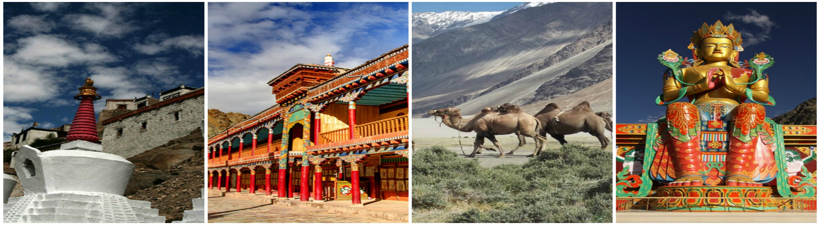
Maintain good diet and avoid consumption of alcohol, sleeping pills or depressant drugs
This package is valid from 05th May’19 till 24th July’19

